SQL Documentation –
Pizza Sales Project

Prepared by: Vatsal
Tools Used: SQL Server, Excel
Date: June 2026

Overview:
This document contains the SQL queries used to analyze the Pizza Sales dataset. The queries were used to calculate KPIs, identify sales trends, analyze product performance, and generate business insights for the dashboard.

- KPI’S

- Total Revenue:
SELECT SUM(total_price) AS Total_Revenue FROM pizza_sales

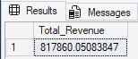

- Average Order Value
SELECT SUM(total_price) / COUNT(DISTINCT order_id) AS Avg_Order_Value
FROM pizza_sales
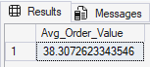

- Total Pizza Sold
SELECT SUM(quantity) AS Total_Pizza_Sold FROM pizza_sales
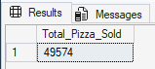

- Total Order
SELECT COUNT(DISTINCT order_id) AS Total_Order FROM pizza_sales
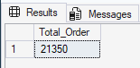

- Average Pizza Per Order
SELECT
CAST(CAST(SUM(quantity) AS DECIMAL(10,2)) / CAST(COUNT(DISTINCT order_id) AS DECIMAL(10,2)) AS DECIMAL(10,2)) AS Avg_Pizza_per_Order
FROM pizza_sales
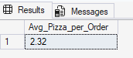

B. Time-Based Analysis

- Daily/Weekly/Quaterly Trends

SELECT DATENAME(dW,order_date) AS Order_day, COUNT(DISTINCT order_id) AS Total_order
FROM pizza_sales
GROUP BY DATENAME(dW,order_date)
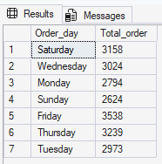

Note: You can also see Montly, Quaterly, Weekly by change window function llike,
For Monthly:
SELECT DATENAME(MONTH,order_date) AS Order_day, COUNT(DISTINCT order_id) AS Total_order
FROM pizza_sales
GROUP BY DATENAME(MONTH,order_date)

As per that you can change and see in different time frame

- Hourly Trends

SELECT DATEPART(HOUR, order_time) AS Order_hour, COUNT(DISTINCT order_id) AS Total_order
FROM pizza_sales
GROUP BY DATEPART(HOUR, order_time)
ORDER BY Order_hour
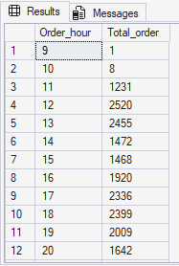

C. Product Analysis

- Sales by Category

SELECT pizza_category,
CAST(SUM(total_price) AS DECIMAL(10,2)) AS category_sales,
ROUND(
SUM(total_price) * 100.0 /
SUM(SUM(total_price)) OVER (),
2
) AS PCT
FROM pizza_sales
GROUP BY pizza_category
ORDER BY category_sales DESC
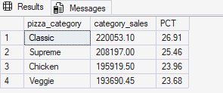

- Sales by Pizza Size

SELECT
pizza_size,
ROUND(SUM(total_price), 2) AS pizza_size_sales,
ROUND(
SUM(total_price) * 100.0 /
SUM(SUM(total_price)) OVER (),
2
) AS PCT
FROM pizza_sales
GROUP BY pizza_size
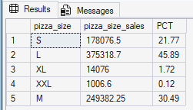

- Top 5 Best and Worst Sellers Pizza

- Best Seller

SELECT
TOP 5 pizza_name,
SUM(quantity) AS total_pizza_sold
FROM pizza_sales
GROUP BY pizza_name
ORDER BY total_pizza_sold DESC
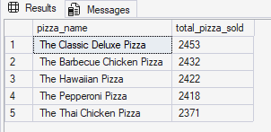

- Worst Sellet

SELECT
TOP 5 pizza_name,
SUM(quantity) AS total_pizza_sold
FROM pizza_sales
GROUP BY pizza_name
ORDER BY total_pizza_sold ASC
